Automated Change Detection User Guide

1. The change detection tool must be used after the automated seep detection tool because it requires its outputs. To use the automated change detection tool, first the user must open ArcMap (ensure the spatial analyst extension is enabled. If not go to Customize-> Extensions then check the box next to spatial analyst)
2. C:\Users\kishii\Desktop\PowerPoint Images\arctoolbox.PNGOnce ArcMap is open, open the ArcToolbox window by clicking
3. In the ArcToolBox window, right click ArcToolbox->Add toolbox.

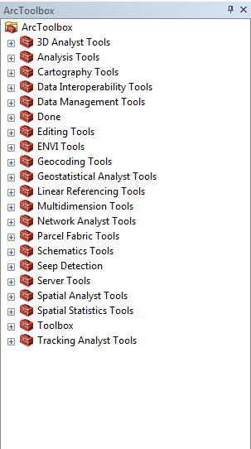

1. Browse to the appropriate folder to add the Change Detection Tool.
2. Once the Change Detection Tool is found, select it and click add.
3. After adding the Change Detection tool, double click the change detection icon (shown below)

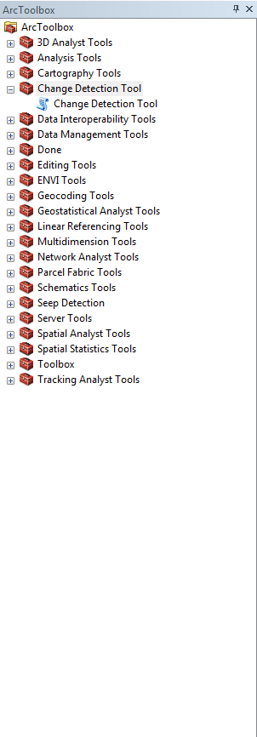

1. After double clicking, the following window should appear:

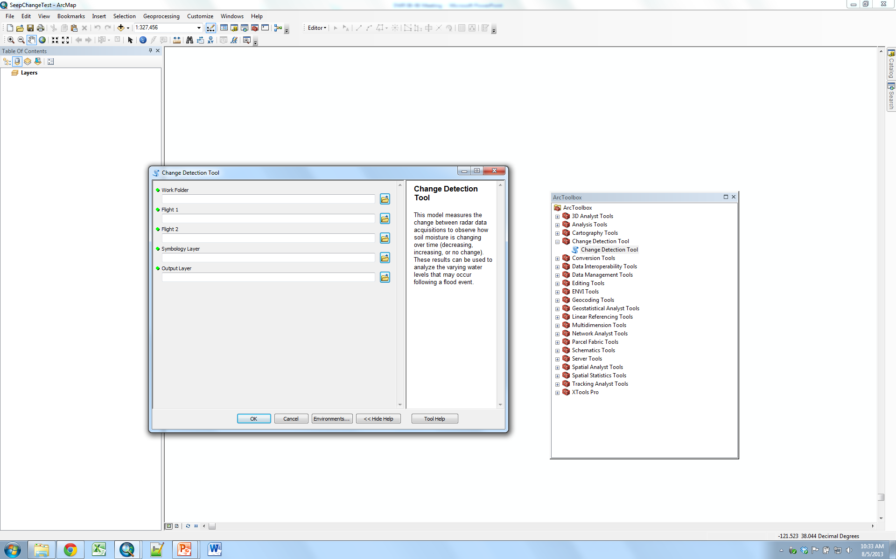

1. Click the folder icon (shown below)



1. Navigate to and select the folder with the raster outputs from the seep detection tool (this is the second empty folder that was made before executing the automated seep detection tool). After selecting it click add (shown below)

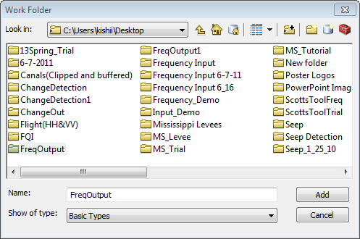

After clicking add, the folder will appear in the change detection window (shown below)

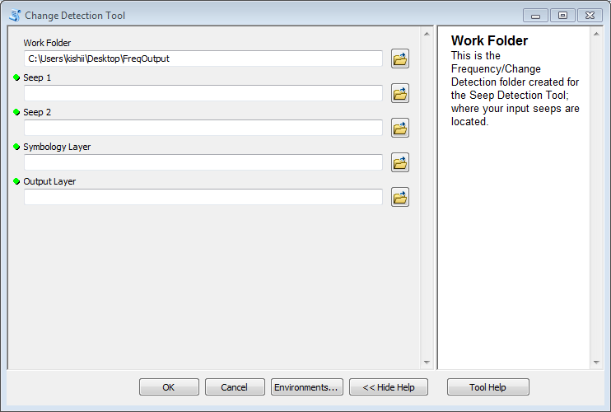

1. Repeat steps 12-13 for the four remaining parameters. Note: Seep 1 is a raster output from the seep detection tool. Seep 2 is a different raster output (different flight/day/time) from the seep detection tool. Symbology layer is the color scheme provided with the tool (Pink=decrease in soil moisture content. Dark blue=increase in soil moisture content. Cyan=Consistent soil moisture content). These colors can easily be changed in ArcMap by double clicking the colored boxes in the Table of Contents. Output layer is the user specified location and name of the layer that will be produced.
2. After all the parameters are selected the seep detection window should like below:

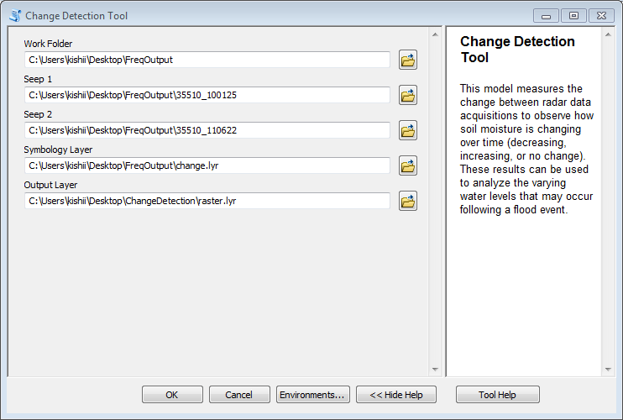

1. Click Ok. The Change Detection Tool will start running. The following window should appear:

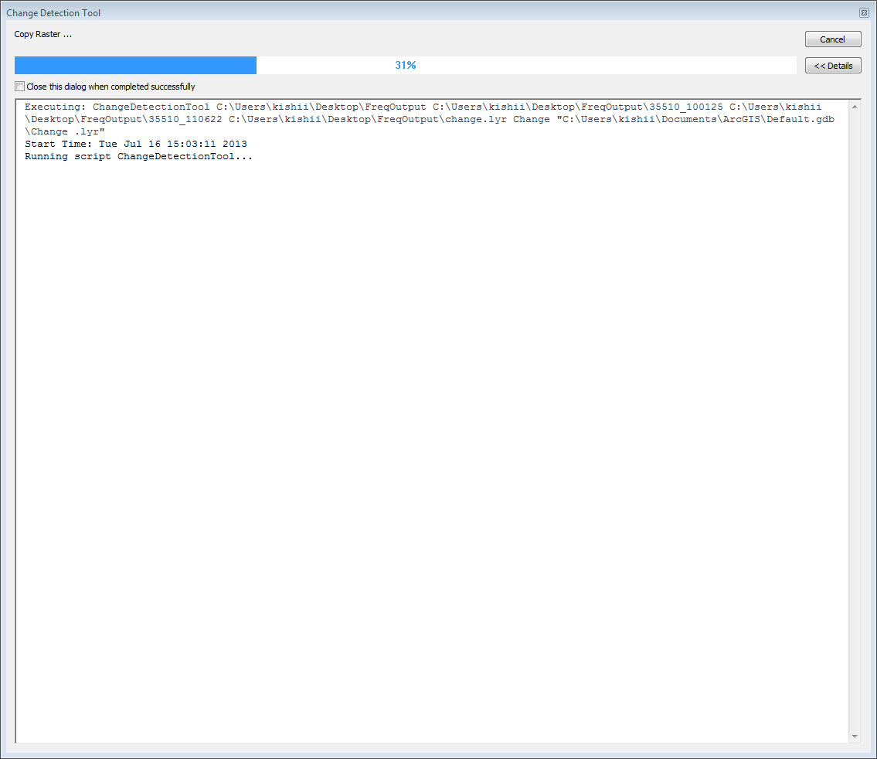

1. After the tool finishes processing, navigate to the work folder and open the kmz file
2. The kmz file will open in Google Earth.
3. 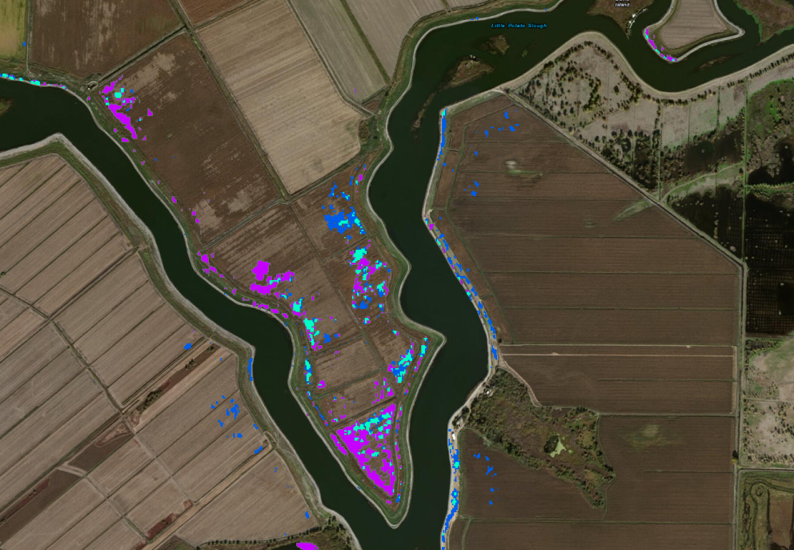Once open in Google Earth, changes in areas identified as potential seepage can be compared between two different images. The output ultimately allows the user to identify how soil moisture has changed over time. (shown below: change detection tool output in Google Earth)